Types of Measures to Ensure Information Security
Objective: To classify the main directions of information security measures (Legal, Organizational, and Technical) and to provide a detailed overview of the specific software and hardware tools used to implement technical controls.

Main questions:
- What are the main areas of information security measures?
- What are software and technical (hardware) measures to protect information?
- How do hardware tools protect against failures and data leakage?
- What are the categories of information security software?

Brief content: This lecture explains that a successful information security program requires a systematic, integrated approach. It categorizes the required actions into three main pillars: Legal (the laws and regulations), Organizational (the policies, procedures, and human-centric controls), and Technical (the hardware and software tools). The lecture then focuses on the Technical measures, detailing specific hardware solutions for protecting against physical threats like power failure (UPS), equipment failure (redundancy), and data leakage (shielding). It concludes by introducing the main categories of software used for protection, such as antivirus, cryptography, and access control systems.
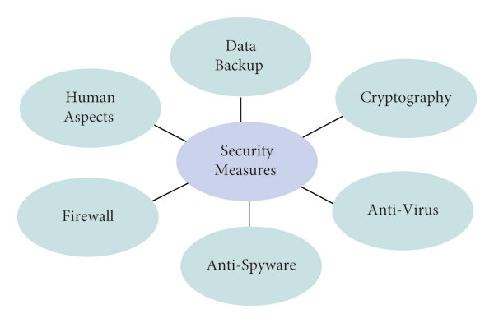
Picture 1-Key Components of Information Security
1. Definitions and Explanations:
Areas of Information Security Measures: Security is a multifaceted activity where success only comes from an integrated approach. The measures are divided into three areas:
Legal Measures: This area involves establishing the formal rules and consequences for security. It includes the development of standards and laws establishing responsibility for computer crimes, the protection of copyrights for programmers, the improvement of criminal and civil law, and the adoption of international treaties.
Organizational Measures: This area covers the human and procedural side of security. It includes the physical security of the computer center, careful personnel selection, segregation of duties (e.g., ensuring no single person has complete control over a critical process), creating disaster recovery plans, and managing access to physical premises (locks, alarms).
Technical Measures: This area includes the specific hardware and software tools used to enforce security rules. It involves protection against unauthorized access, reservation (redundancy) of critical computer subsystems, fire/water detection, and backup power systems.
Potential Threats Addressed by Technical Measures:
Equipment Failures: Loss of information due to power outages, disk system failures, server malfunctions, etc.
Incorrect Program Operation: Data loss or change due to software errors or infection by computer viruses.
Unauthorized Access: Unauthorized copying, destruction, or falsification of information; viewing of confidential information.
Staff and User Errors: Accidental destruction or alteration of data, or incorrect use of hardware/software.
Hardware Security: This refers to special tools that are directly part of the hardware and perform protection functions.
Power Failure Protection: The most reliable method is the use of Uninterruptible Power Supplies (UPS). These devices provide power for a short time, sufficient to store information and perform a correct shutdown, or to bridge a momentary outage. Many modern servers also have duplicated (redundant) power supplies.
Processor Failure Protection: This is achieved through the backup (redundancy) of critical subsystems. An example is symmetric multiprocessing, where if one processor fails, a second one continues the work without interruption to the users.
Storage Device Failure Protection: This is crucial for data safety.
Backup Systems: Creating copies of data on tape recorders (streamers), reusable compact discs, or dedicated archive servers. Experts recommend storing critical backups in a separate building.
Mirroring (Redundancy): Using a mirrored hard drive system (like RAID 1). A backup copy of the information is formed in real-time, so if one hard drive fails, the system immediately starts working with the other.
Leakage Protection (Electromagnetic Radiation): The passage of electrical signals through PC circuits and cables creates spurious electromagnetic radiation (PEMI), which can be intercepted from tens or even hundreds of meters away. The main sources are monitors, printers, and the CPU. Protection methods include shielding (of rooms or equipment), filtering (on power lines), and grounding.
Information Security Software: This refers to special programs included in the system software to provide data protection functions. The main categories include:
- Data archiving tools
- Antivirus software
- Cryptographic tools (encryption)
- Means of user identification and authentication
- Access controls
- Logging and audit tools
2. Practical Relevance and Key Takeaways:
This lecture builds upon the previous two by answering the question: "Now that we know what we are protecting (Lecture 1) and what we are protecting against (Lecture 2), how do we actually protect it?"
Defense in Depth: The key takeaway is that security is not one single product (like an antivirus). It is a layered system of Legal, Organizational, and Technical controls. A legal policy is useless without organizational procedures to enforce it, and technical tools are useless if an unauthorized person can simply walk into the server room.
Hardware Security is the Foundation: The lecture emphasizes that software security (like passwords) is irrelevant if the physical hardware fails. Protecting against physical, real-world threats like power outages (UPS), disk failures (RAID/Backups), and even electromagnetic eavesdropping (Shielding) is the foundational layer upon which all other security is built.
Controls Map to Threats: The technical measures described are not random; they are direct countermeasures to the threats. UPS and redundancy combat Availability threats. Backups and mirroring combat Integrity threats (data loss). Access control and cryptographic software (introduced here) combat Confidentiality and Integrity threats.
3. Functional Classification of Controls
Beyond their type (Legal, Organizational, Technical), measures can also be classified by their function relative to a security incident. This framework helps in designing a layered defense.
Preventive Controls: These are measures designed to stop a threat from succeeding in the first place. They are the first line of defense.
Examples from this lecture: Access controls and Authentication (prevent unauthorized access), Cryptographic tools (prevent data from being read if intercepted), UPS (prevent power failure), Hardware redundancy (prevent processor failure), Shielding (prevent electromagnetic leakage), and Organizational measures like locks on doors.
Detective Controls: These are measures designed to identify and report that a threat or incident is in progress or has already occurred. They are the second line of defense.
Examples from this lecture: Logging and audit tools (to detect what happened), Antivirus software (in scanning mode, to detect an existing infection), and technical systems like fire/water detection alarms.
Corrective Controls: These are measures designed to remediate the impact of an incident and restore the system to normal operation. They are the final line of defense.
Examples from this lecture: Backup systems (which allow data to be restored after loss), Mirrored hard drives (which provide an immediate failover to a clean copy), and Organizitional measures like Disaster Recovery Plans (which outline the steps to recover the entire business).

4. Control questions:
- What areas of information protection measures do you know?
- List the main software and hardware tools for protecting computer information.
- What are the means of protection against power failures?
- What are the means of protection against malfunctioning processors and storage devices?
- What are the means of protection against information leaks due to the formation of electromagnetic radiation?
- What relates to information security software?
5. Recommended literature:
- Partyka T.L., Popov I.I. Information Security. Textbook for students of vocational schools. M.: FORUM: INFRA - M, 2002.
- Raghavan, S. Cyber Security: Concepts, Methodologies, Tools, and Applications; IGI Global: Hershey, PA, USA, 2022.
- Stallings, W.; Brown, L. Computer Security: Principles and Practice, 4th ed.; Pearson: London, UK, 2021.
- Pfleeger, C.; Pfleeger, S.; Margulies, J. Security in Computing, 6th ed.; Pearson: London, UK, 2022.
- Kim, D.; Solomon, M.G. Fundamentals of Information Systems Security, 4th ed.; Jones & Bartlett Learning: Burlington, MA, USA, 2021.
- Whitman, M.; Mattord, H. Principles of Information Security, 8th ed.; Cengage Learning: Boston, MA, USA, 2023.

